

WingWatch Read.Me

OPSC7312 POE Final



[Date]

[Company name]

[Company address]

Contents

Introduction 2

How to set up the app 2

How to create an emulator 5

How to use the Application: 7

Register Page 8

Login Page 9

Profile and Settings page 10

Observation Page 12

New Sightings 14

Map Page 15

Community & Achievements Page 16

Journal Page 18

**By:**

**Zànne Smit - ST10082074 - (VixeyPopcorn)(code)**

**Saurav Sewparsad - ST10083544 - (docs)**

**GitHub:**

[**https://github.com/VixeyPopcorn3/OPSC7312-POE-WingWatchApp.git**](https://github.com/VixeyPopcorn3/OPSC7312-POE-WingWatchApp.git)

# Introduction

In this word document, We will give a step by step guide in:

* How to set up the app,
* How to create and emulator
* How to navigate through the app.

## How to set up the app

First you will need to download the code ZIP file from vclearn to your desktop.

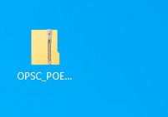

After saving the zip file to your desktop right click and extract the files, you can save the files anywhere, but the desktop is the best place to find them.

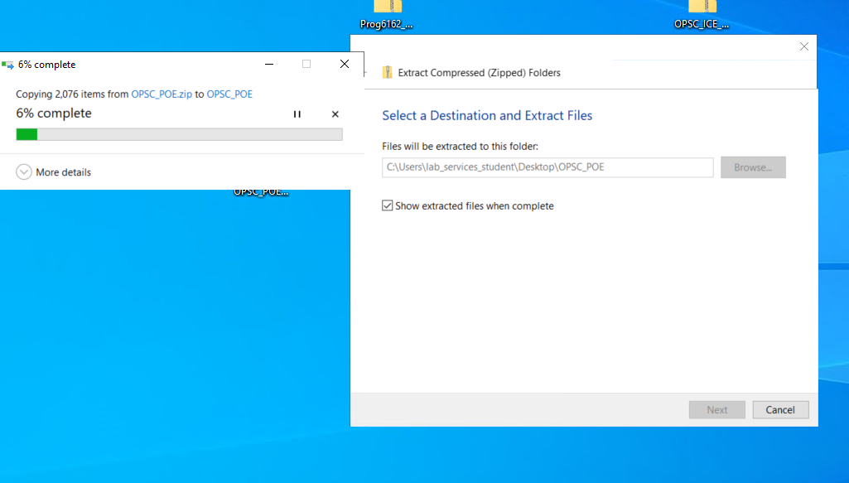

After extracting the file, you should have a folder like this below

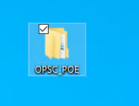

After you have this file, open android studio. Click on the file tab at the top left corner of the screen, it will give more options. Look for the open folder tab and click it.

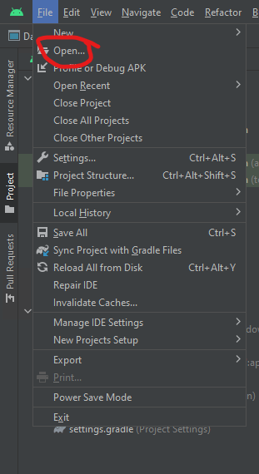

After clicking the open folder icon you will be taken to another screen where you will need to find the folder you previously extracted. Find the folder, for me I had the folder in the Desktop(I highly recommend you save the folder in the desktop).

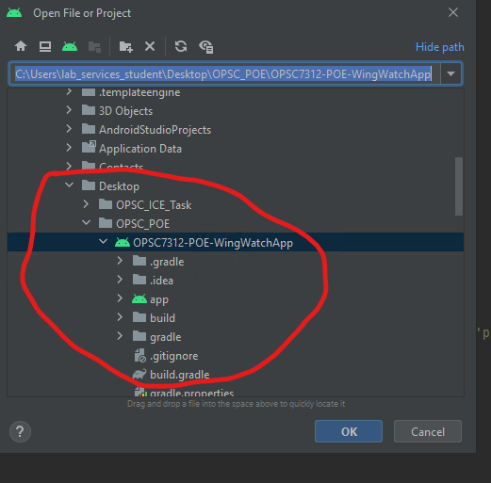

Once you have found the application, click it then click the ok button to open it.

Once the application is opened, let android studio build the gradle and load the project.

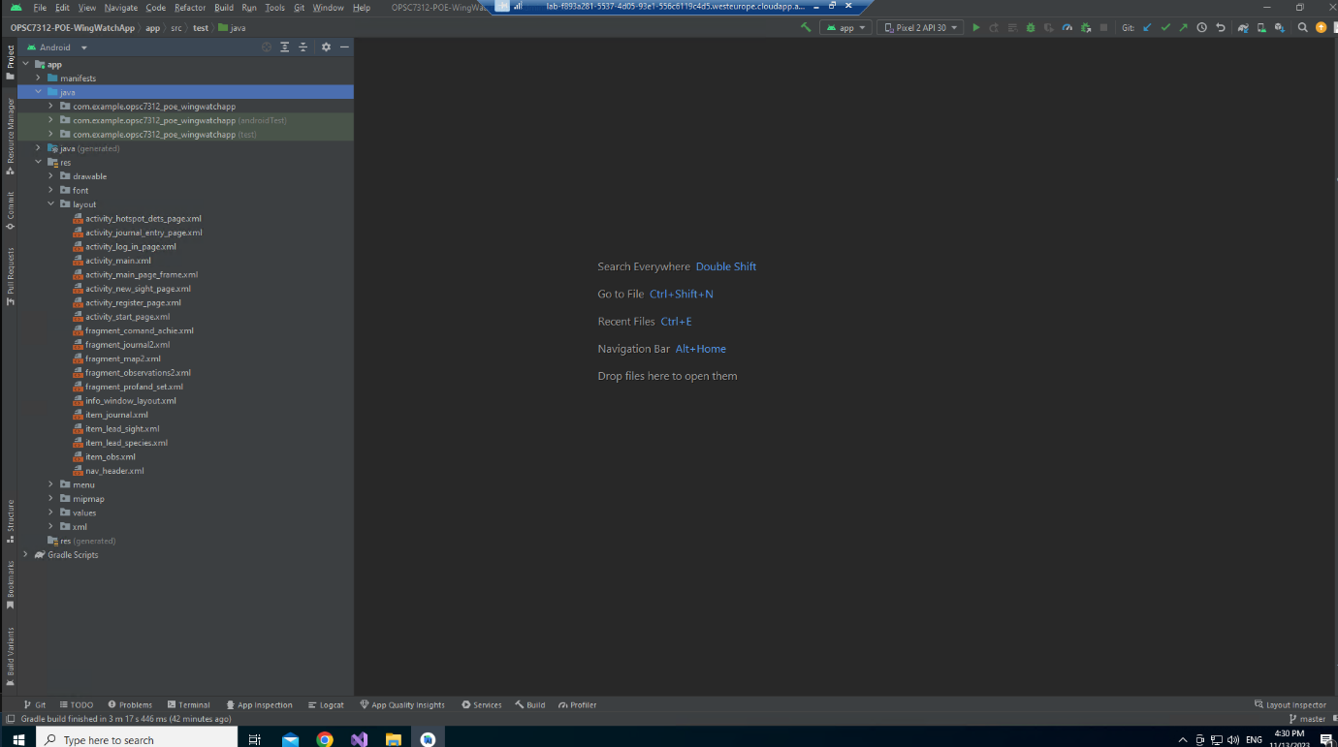

When the application is fully finished building you can then run the application in the emulator.

## How to create an emulator

To create an emulator, click on the second drop down bar that looks like a phone

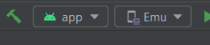

After clicking it, select the device manager tab. The a new form will open in the android studio. You will then create a new device.

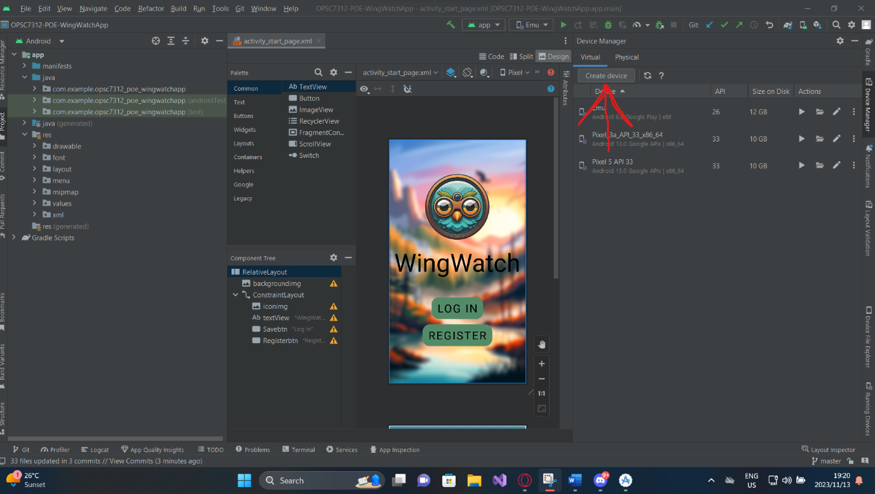

After clicking the Create Device button, you will then be asked to select any type of phone. I picked the pixel 2 phone.

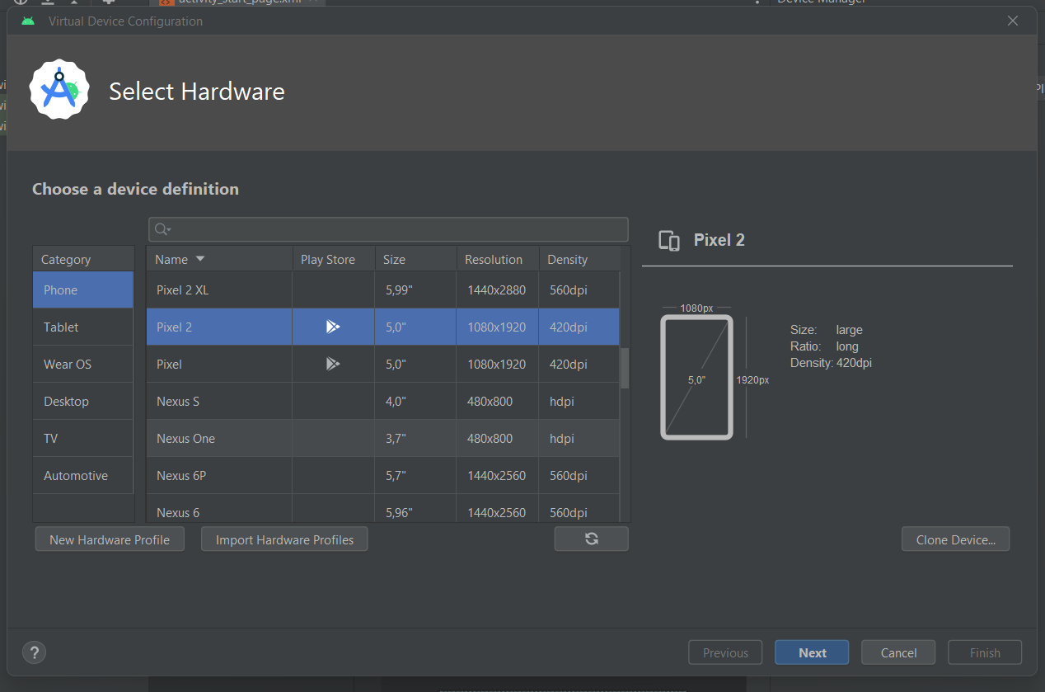

Once u selected the type of phone click next.

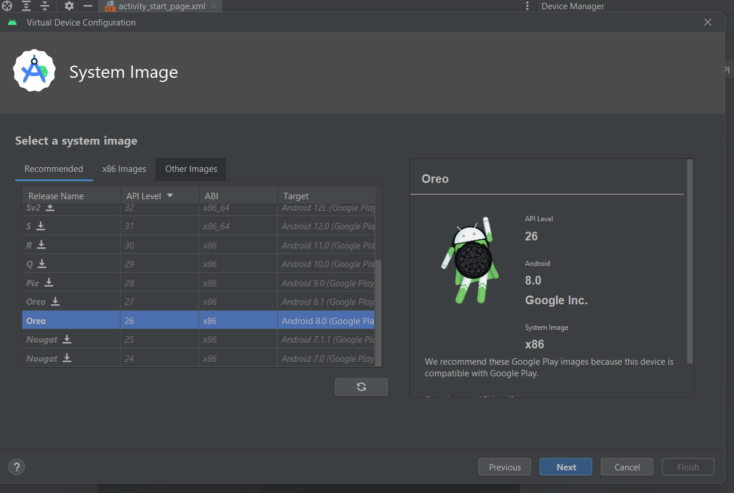

You will then need to pick the type of system for the phone, I recommend the Oreo system. Once you have selected the system type click next.

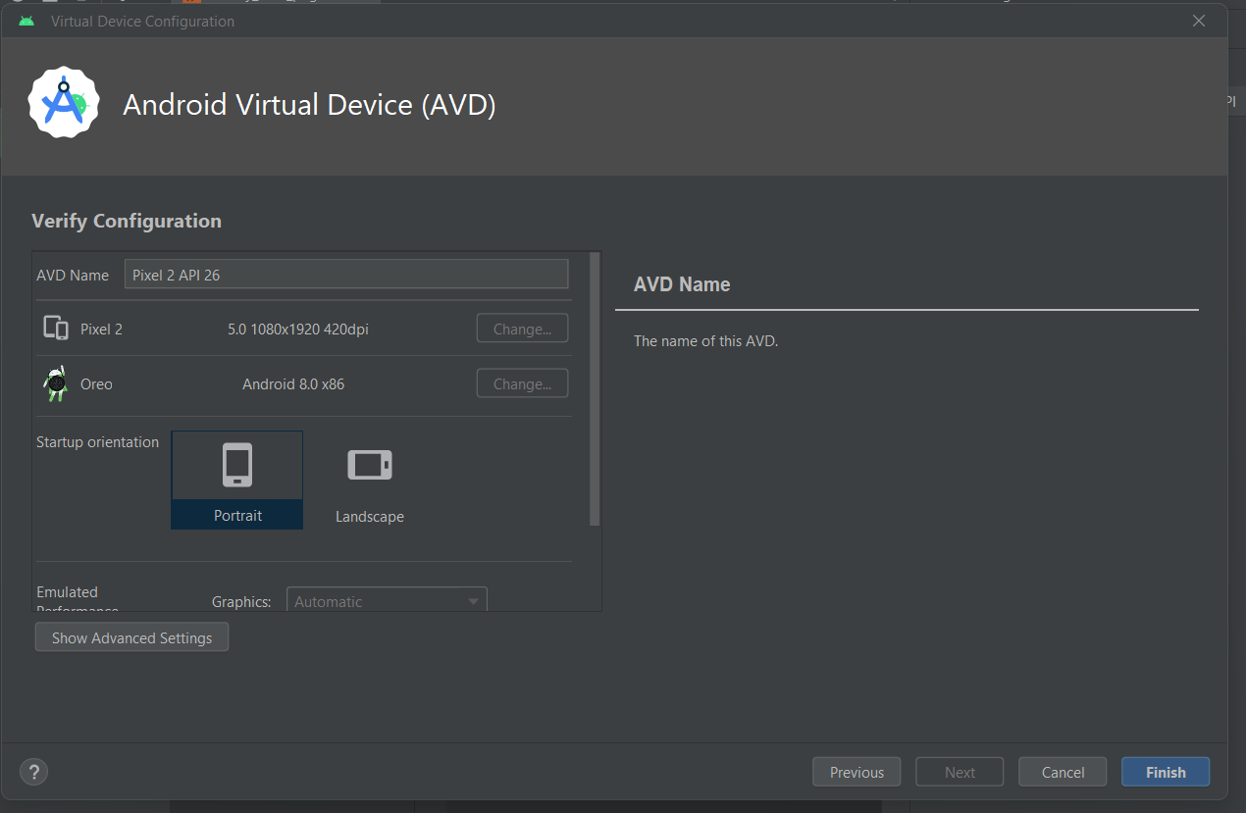

Name the emulator anything you want and click finish. You will then have a fully running emulator.

## How to use the Application:

To run the application, click on the green play button at the centre top of the screen. You will then need to let the Gradle build. Once the Gradle is done building the application will run.

Once the user clicks the power button of the emulator the app will open. The user will be sent to the start screen. If the user has an account they can click on the login button, but if the user does not have an account then they need to click the registration button.

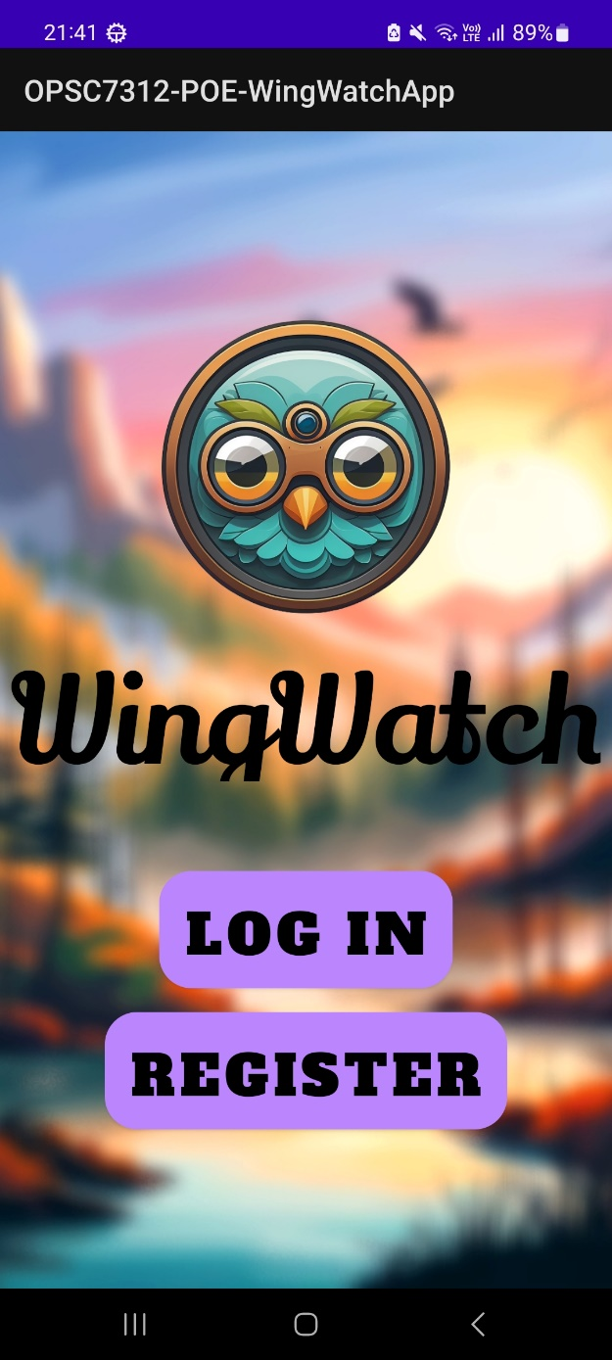

### Register Page

When the user clicks the registration button, they will be redirected to the register page.

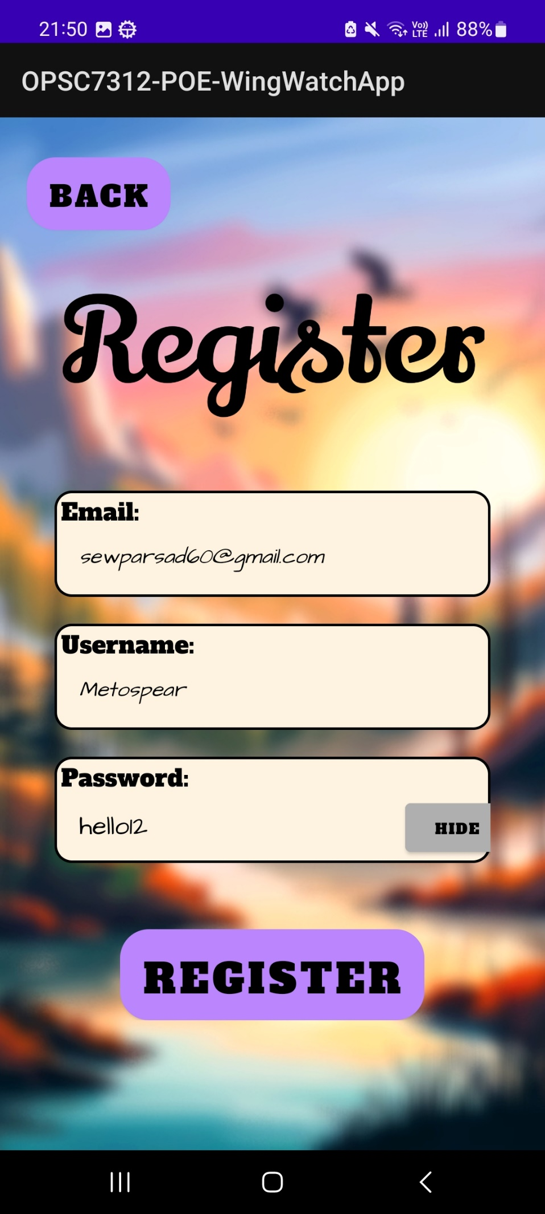

The user needs to fill in all the fields to register. Once the user has filled in all the details they can scroll down and click the register button and the user will be registered. The user information will be authenticated and then be sent to the database if authorised.

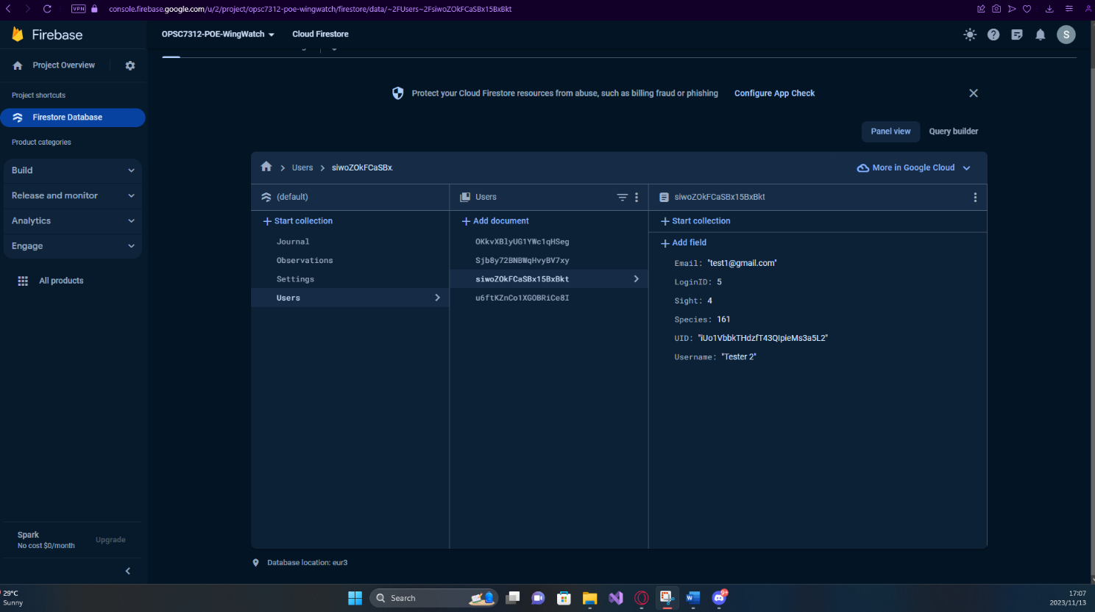

### Login Page

If the user has an account created already, they can click the login button and be redirected to the login page. The user needs to enter their email and password to login.

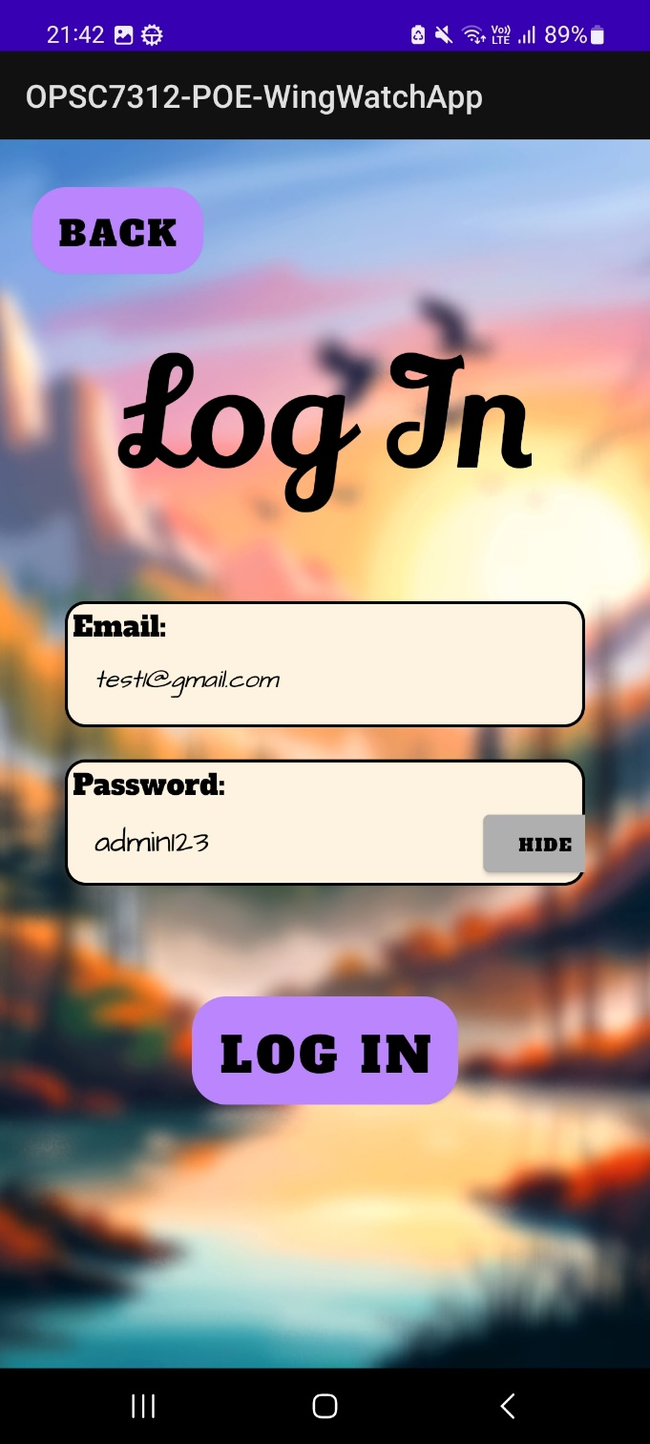

### Profile and Settings page

When the user logs in they will be greeted with the profile and setting page where the user will be able to select the distance of the bird hotspots in the area. They can change between metric or imperial system. It will even show the users details on the screen.

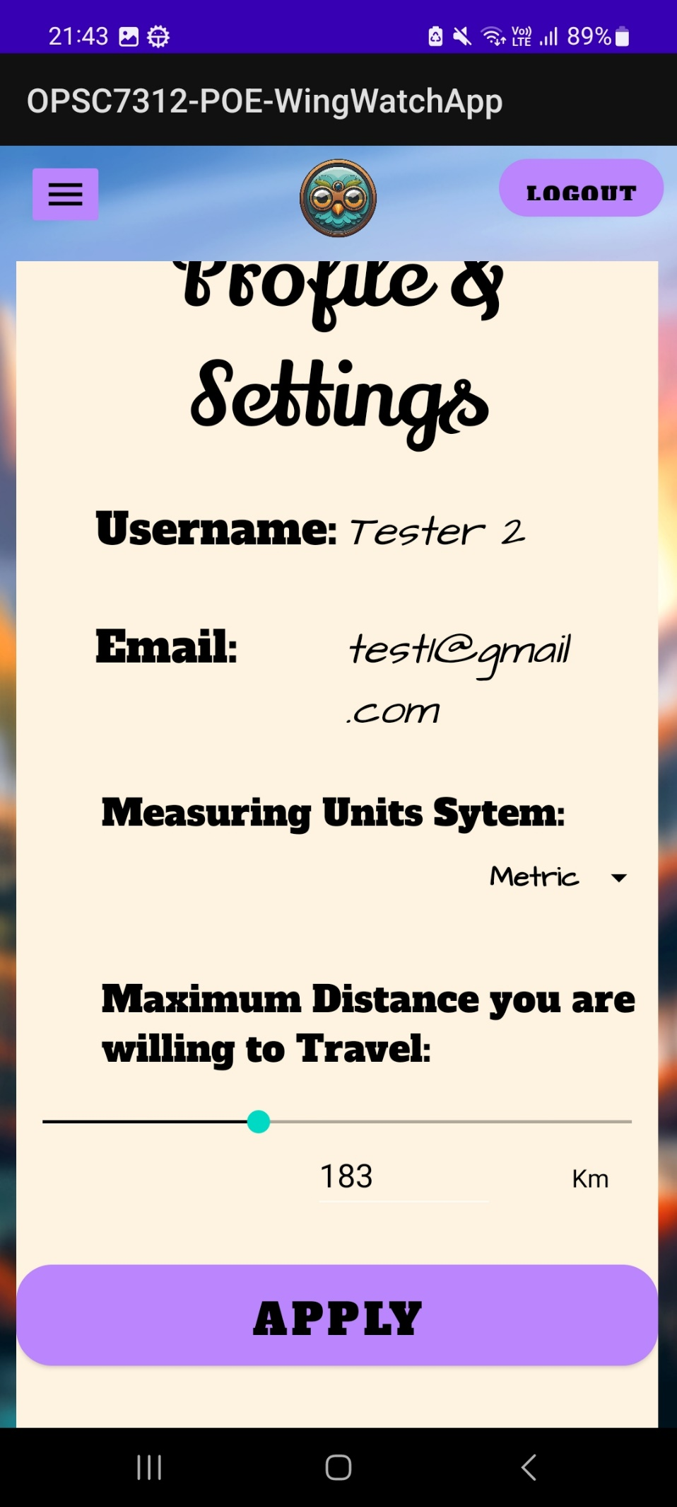

Once the user has entered their preferences into the setting page, they can click the apply button and all their setting will be applied to the map and be saved to the database.

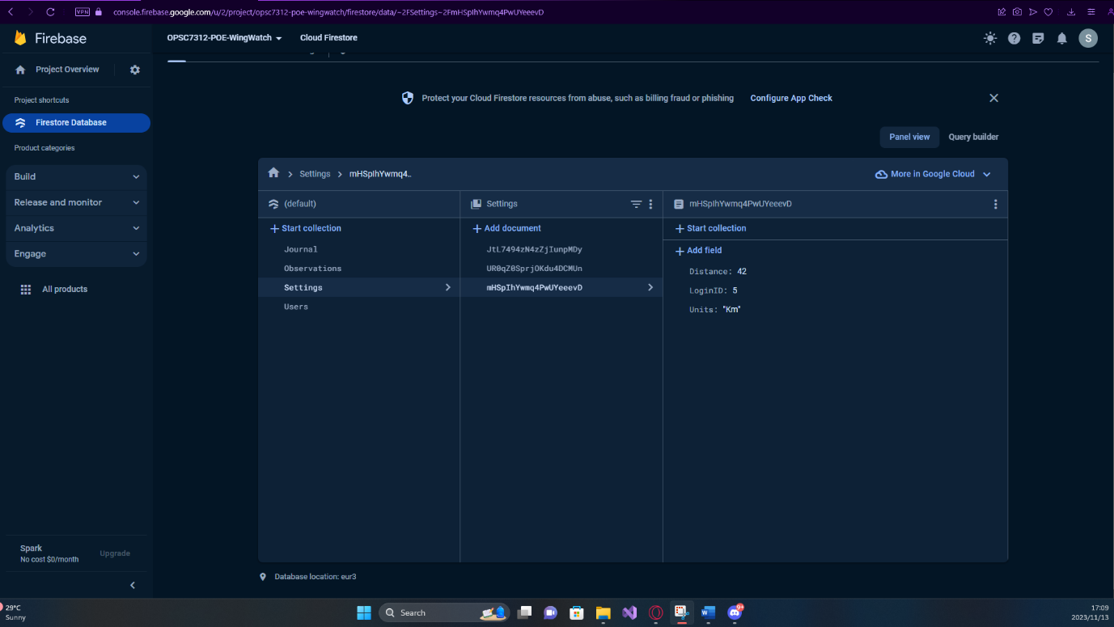

In the top left corner, there is a button with 3 lines (burger menu). The user need to click it to navigate to the other screens in the app.

Once the user clicks the burger menu, they will see all the other pages, such as the Observation page, The Map, as well as our extra features like Community & Achievements and a Journal.

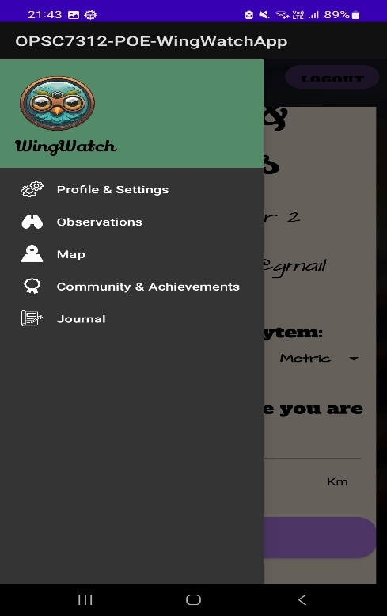

We will go down the list and start with the Observation page.

### Observation Page

In the observation page the user can enter sighting of new bird in the area. The user can also filter the observations by selecting the location and the date. Once the setting has been selected, the user can press the “Filter” button and only observations with those requirements will appear.

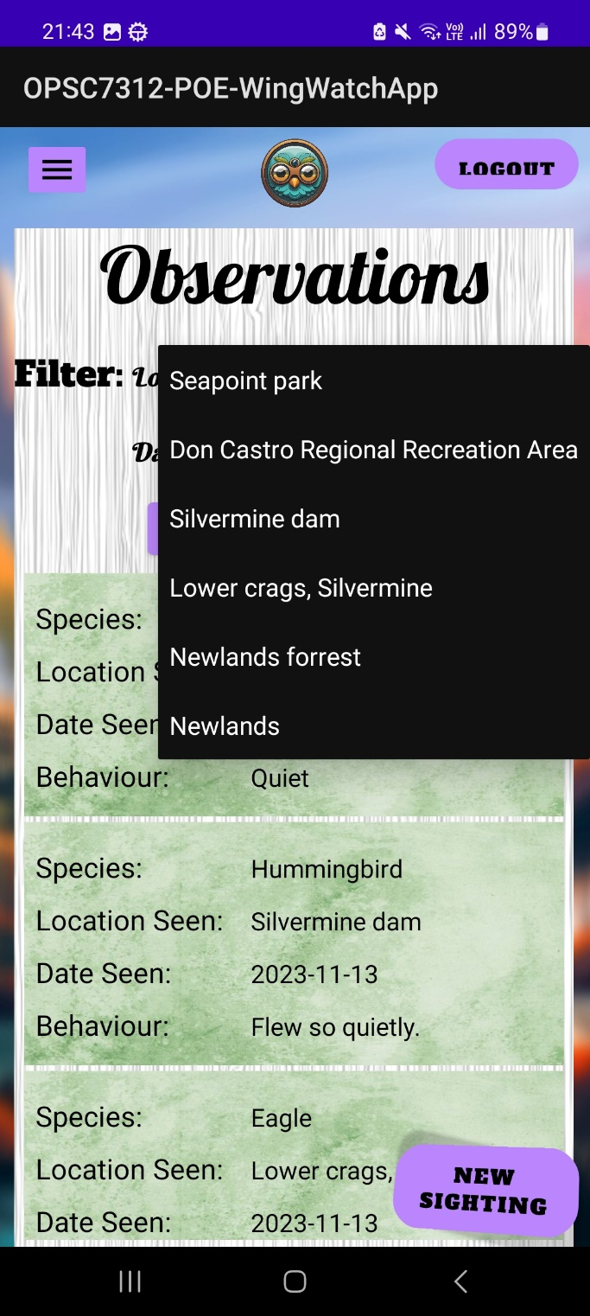

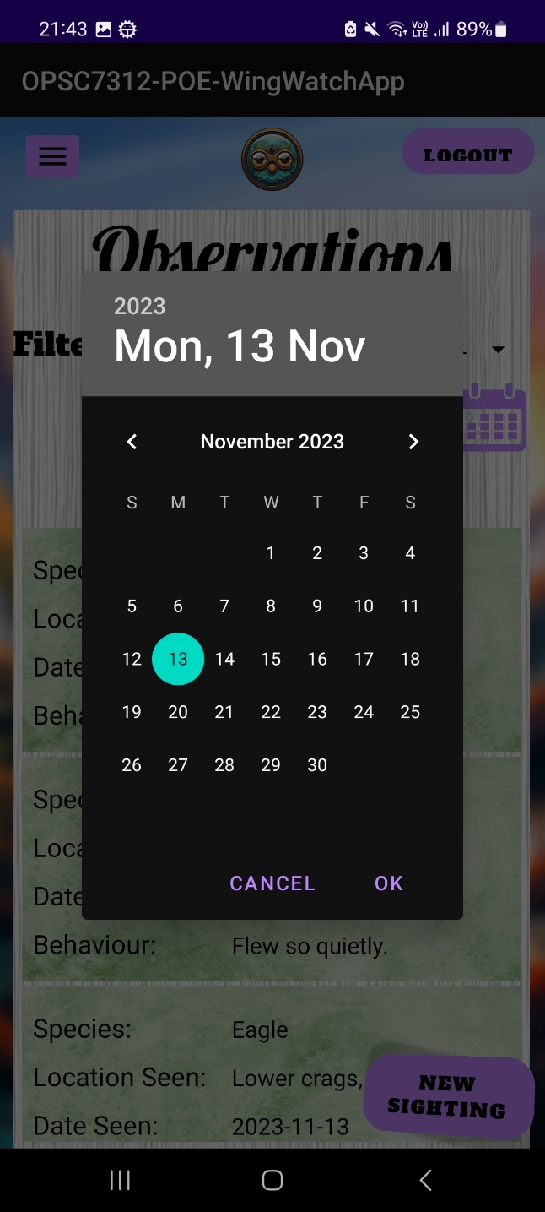

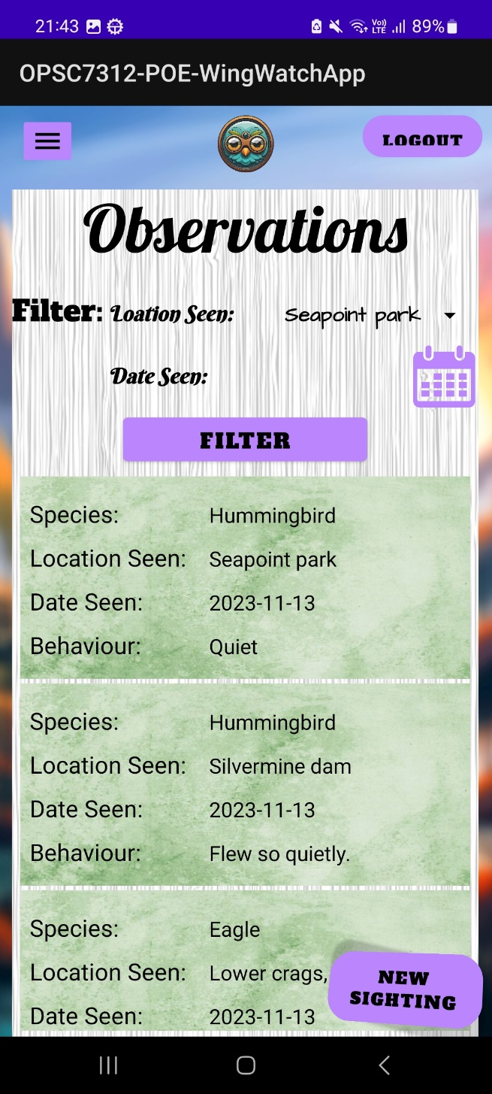

If the user wants to add more Observations, they just need to click the new sighting button in the bottom right corner of the screen.

### New Sightings

When the button is clicked, the user will be redirected to the sighting page. This page will allow the user to write down:

* what type of bird was found,
* hotspot it was found,
* behaviour of the bird
* any further notes the user would like to take note of.
* Check box, where the user can check yes if the new sighting was made in the area they are in or they can leave it unchecked.

Once the user enters the details and clicks the save button, the information will be sent to the database and be displayed in the observations page. 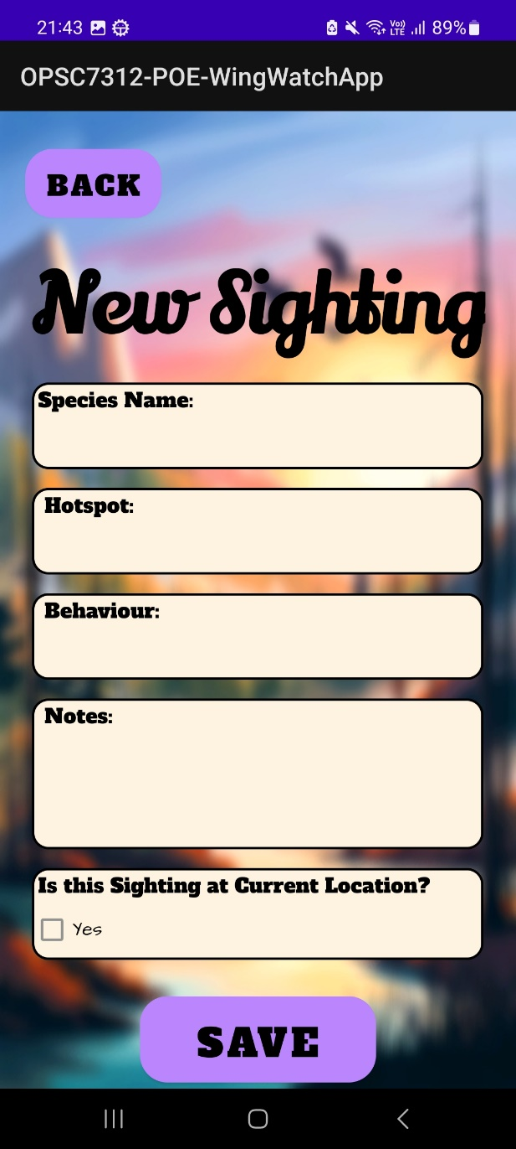

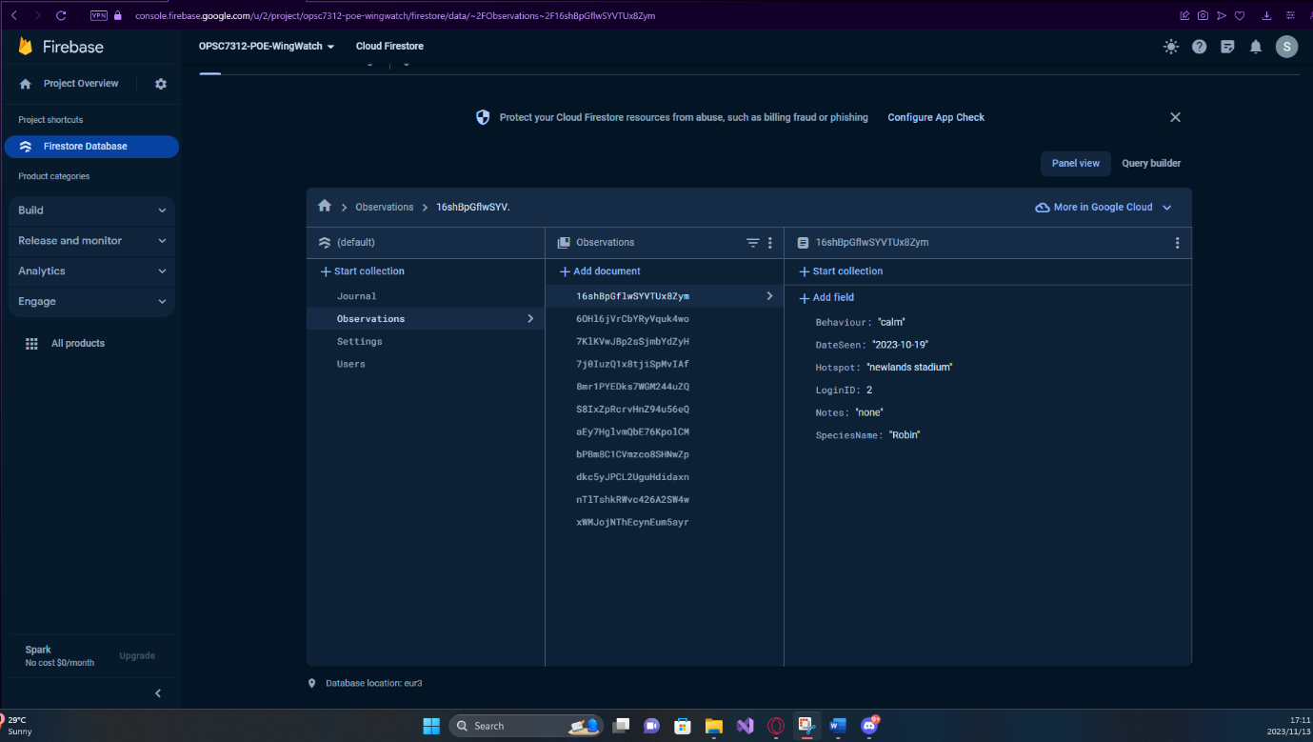

### Map Page

The map page will open up and centre itself around the user’s current location. Around the user will be the users observations that will be in blue markers, and the bird hots spots will be displayed as red markers. The user can move the map around to see any other bird hotspot in the area around them and can also get directions to the hotspot.

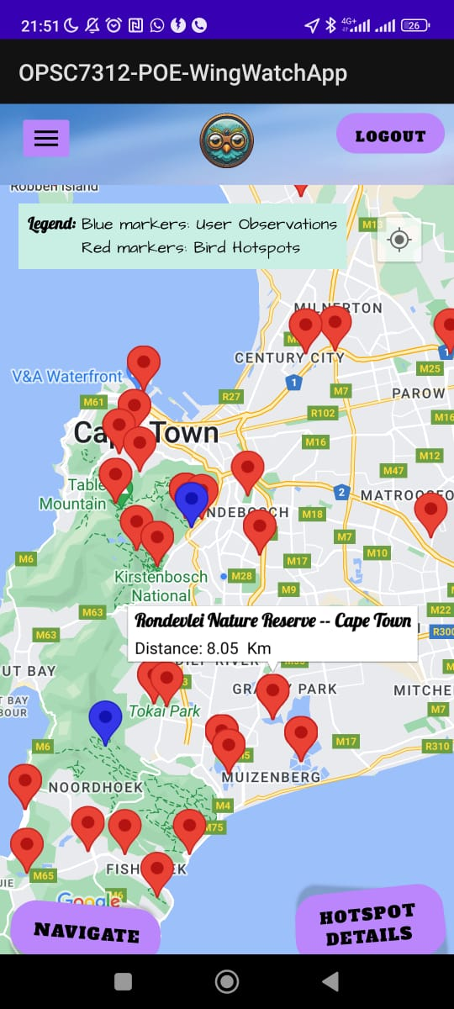

There are 2 buttons on the map that will only be displayed when the user selects a bird hotspot. One is the hotspot details and the second will be the navigation. The hotspot detail button will bring up the hotspot page where the user can view all the details about the hotspot selected.

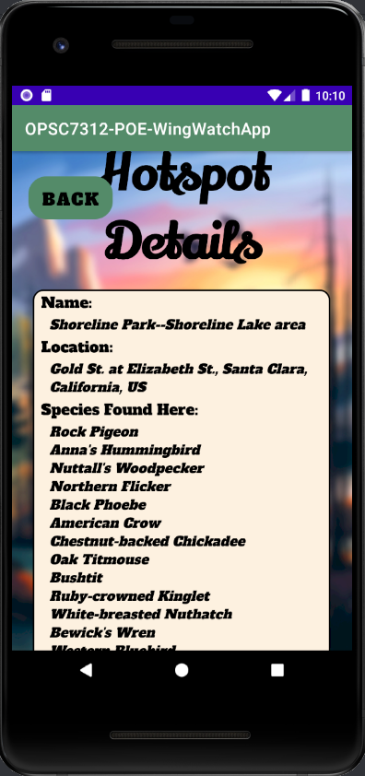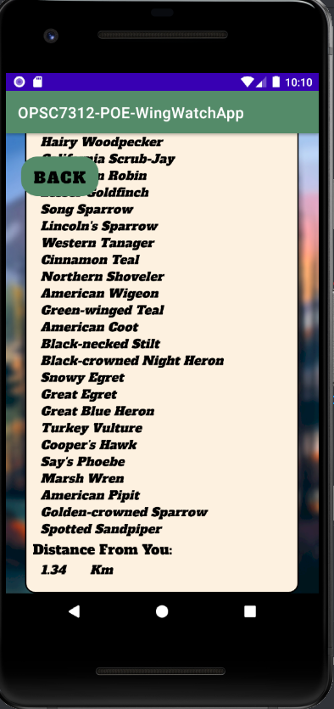

The navigation button will take the user out of the app and redirect them to the google maps app and offer them the best route to the selected hotspot.

### Community & Achievements Page

The community and achievement page is a gamification feature added to the app to keep users interested and encourages users to find more species of birds. The user’s username will be displayed along with the details of how many sightings they have made along with the number of species they have found. Depending on how many species the user has found they will be given a medal ranking and will also be placed in the leader board.

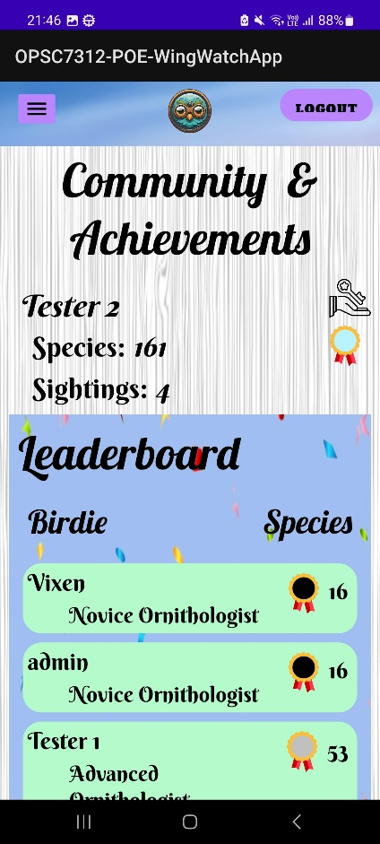

The achievement has a legend that will inform the user on the ranking each medal has as well as their ranking badge.

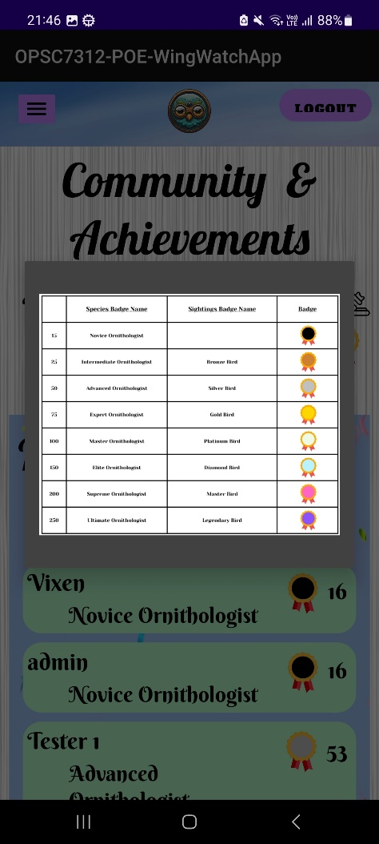

The leader board will display other users that are active on the application and their badges (Ornithologist for Species and Bird for Sightings) along with their medal ranking.

### Journal Page

The Journal page is where the user can make any extra notes about what they have seen that day. The date will be automatically recorded after the user makes the journal entry. To enter a new journal entry, they user can see at the bottom right of the screen will be a button, the user can click the button and be redirected to journal entry page.

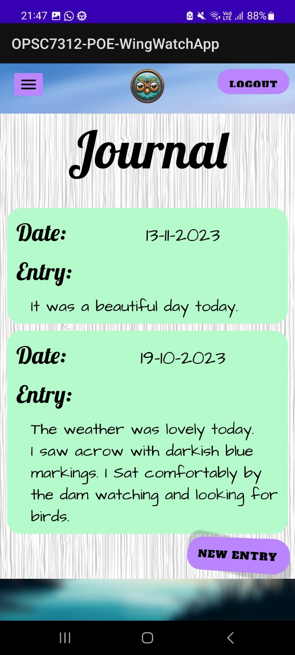

The user can enter anything they want into the entry and once the user is happy with the entry they have made, they can click the save button and the entry will be saved to the database and shown in the journal page. All the users journal entries will be sorted from newest to oldest.

